Name: Rishika Soni
RollNo: 48
Sec/Batch: A3
Practical No.5
AIM: Study and Implementation of different types of joins like cross join,
natural join, inner join, and outer joins.
DEPOSIT: Actno, Cname, Bname, Amount, Adate
BRANCH: Bname, City
CUSTOMERS: Cname, City
BORROW: Loanno, Cname, Bname, Amount
Emp (empno, ename, job, mgr, hiredate, sal, comm, deptno)
Dept (deptno, dname, loc).

Deposit Table:
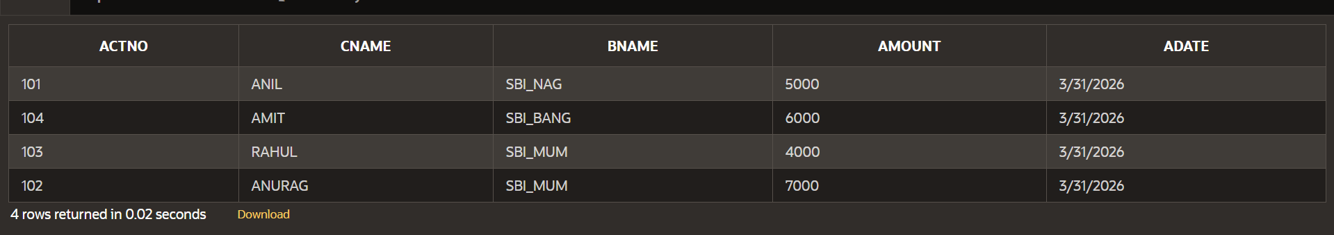

Branch Table:
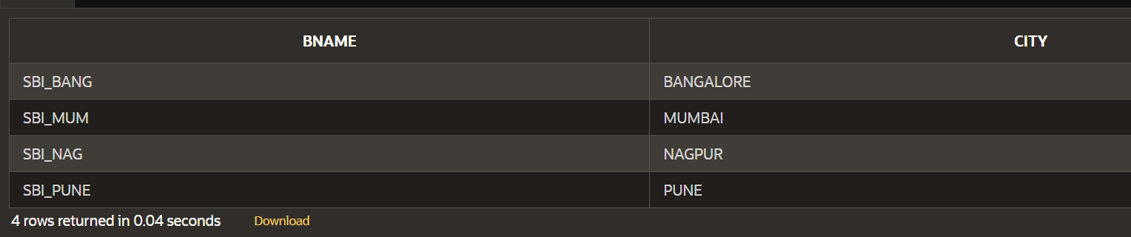

Customer Table:
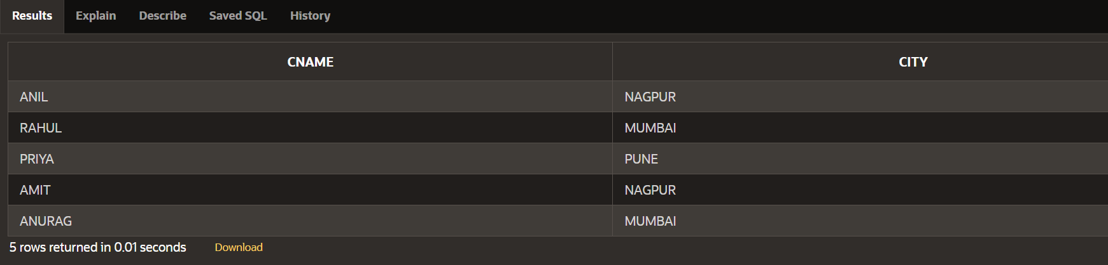

Borrow Table:
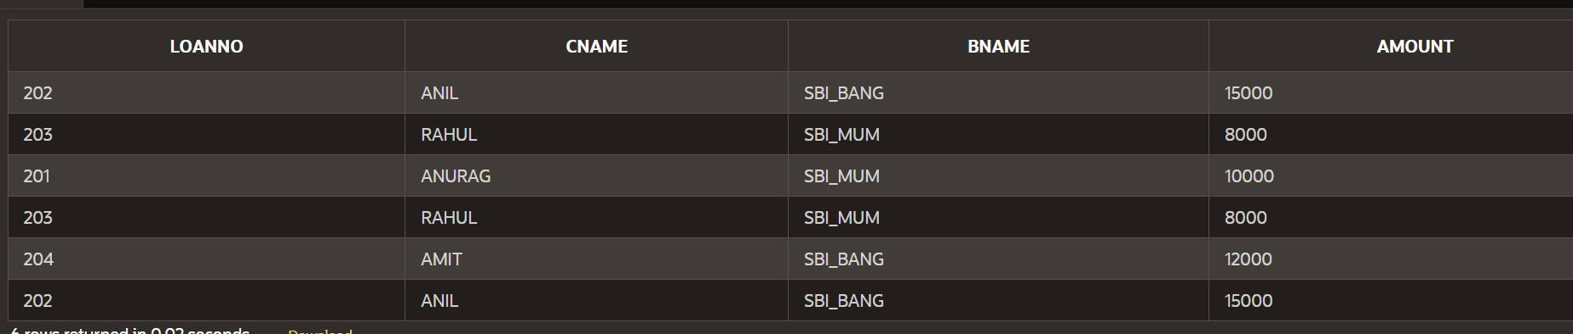

Emp Table:
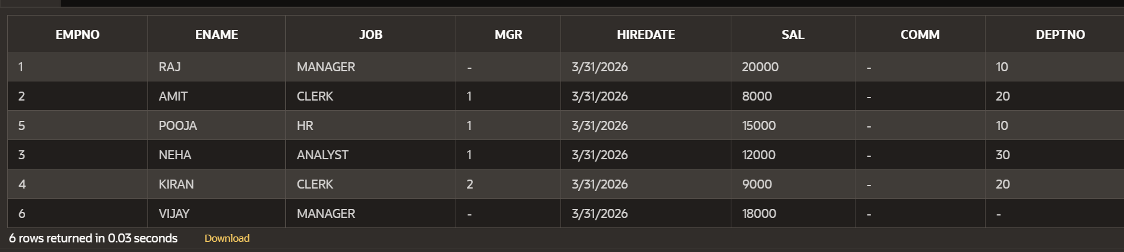

Dept Table:
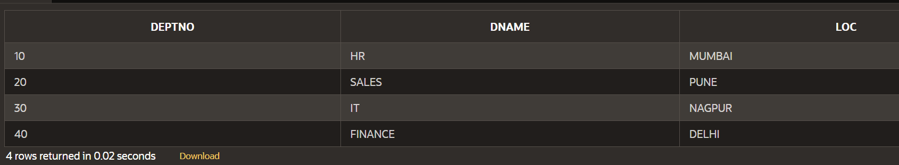

1. Find the details of customer Anurag.
SELECT * FROM Customer WHERE cname = 'ANURAG';
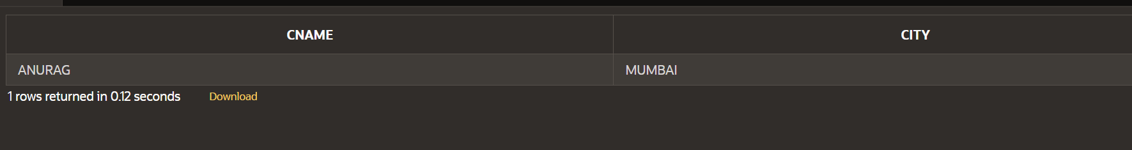
2. Find the names of customers who are borrowers and depositors and having
living city Mumbai.
SELECT c.cname FROM Customer c
JOIN Borrow b ON c.cname = b.cname
JOIN Deposit d ON c.cname = d.cname
WHERE c.city = 'MUMBAI';
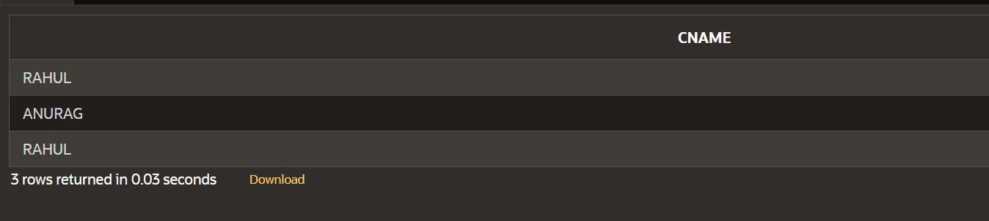
3. Find the name, department number, and department name of all employees.
SELECT e.ename, e.deptno, d.dname FROM Emp e
JOIN Dept d ON e.deptno = d.deptno;
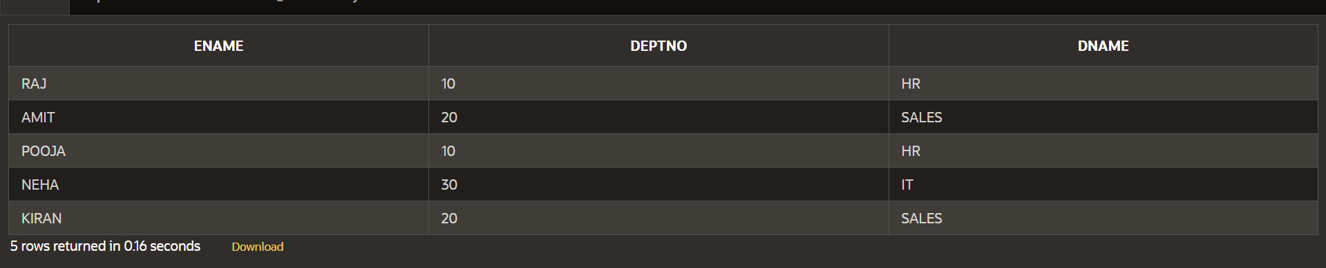

4. Display all jobs that are in department 10. Include the location of the
department in the output.
SELECT e.job, d.loc FROM Emp e
JOIN Dept d ON e.deptno = d.deptno
WHERE e.deptno = 10;
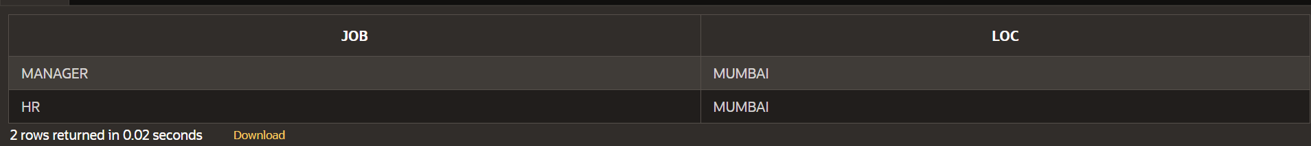

5. Find the employee name, department number, and department name for all
employees who work in PUNE.
SELECT e.ename, e.deptno, d.dname FROM Emp e
JOIN Dept d ON e.deptno = d.deptno
WHERE d.loc = 'PUNE';
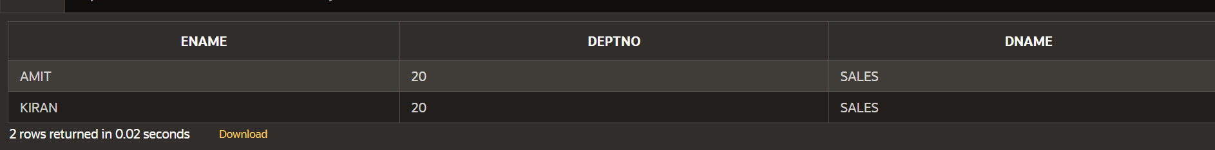

6. Find the name, account no, amount and city of customer ANIL.
SELECT c.cname, d.actno, d.amount, c.city FROM Customer c
JOIN Deposit d ON c.cname = d.cname
WHERE c.cname = 'ANIL';
7. Find the names of customers who are borrowers and depositors.
SELECT cname FROM Borrow INTERSECT SELECT cname
FROM Deposit;
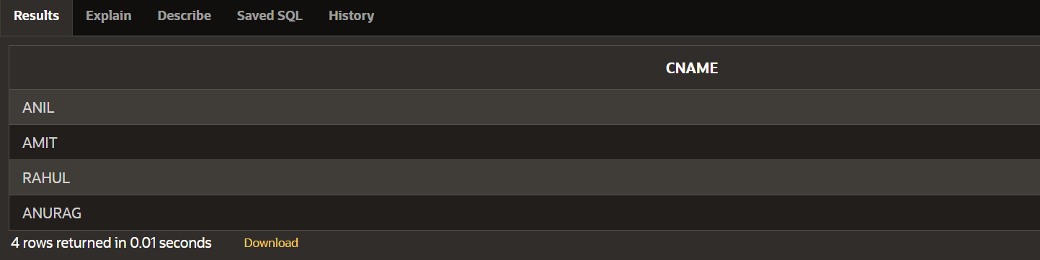
8. Find the names of customers who are borrowers and depositors and having
living city Nagpur and branch city Banglore.
SELECT c.cname FROM Customer c
JOIN Borrow b ON c.cname = b.cname
JOIN Deposit d ON c.cname = d.cname
JOIN Branch br ON d.bname = br.bname
WHERE c.city = 'NAGPUR'
AND br.city = 'BANGALORE';
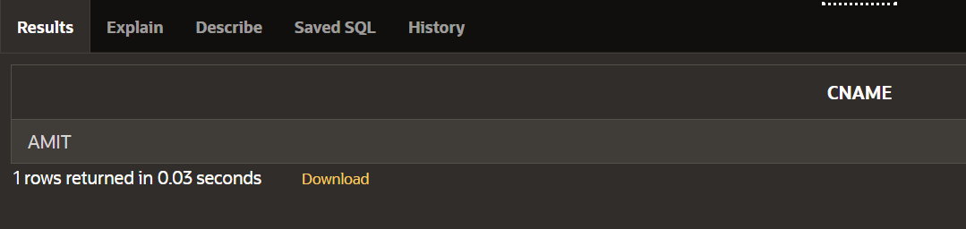
9. Find the name, department number, and department name of all employees
having salary &gt;10000
SELECT e.ename, e.deptno, d.dname FROM Emp e
JOIN Dept d ON e.deptno = d.deptno
WHERE e.sal > 10000;
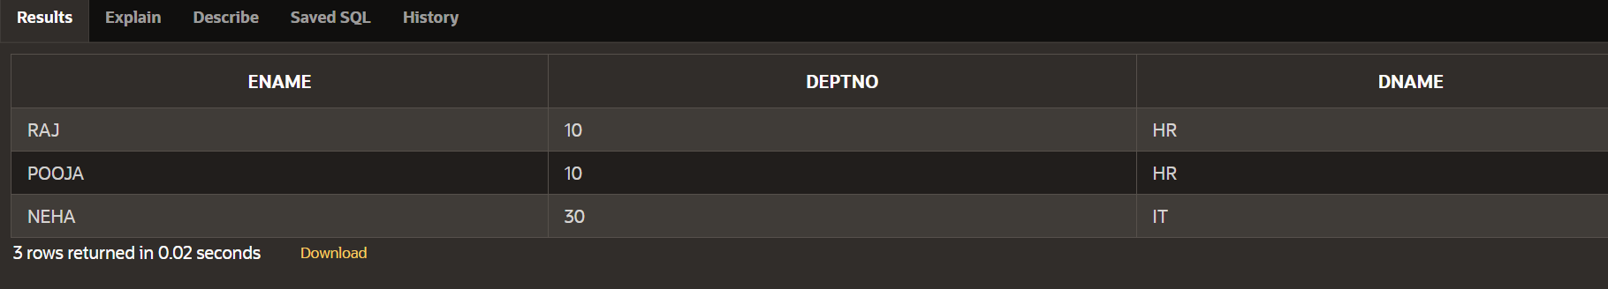
10. Retrieve all employees and their department names, including those without a
department.
SELECT e.ename, d.dname FROM Emp e
LEFT JOIN Dept d ON e.deptno = d.deptno;
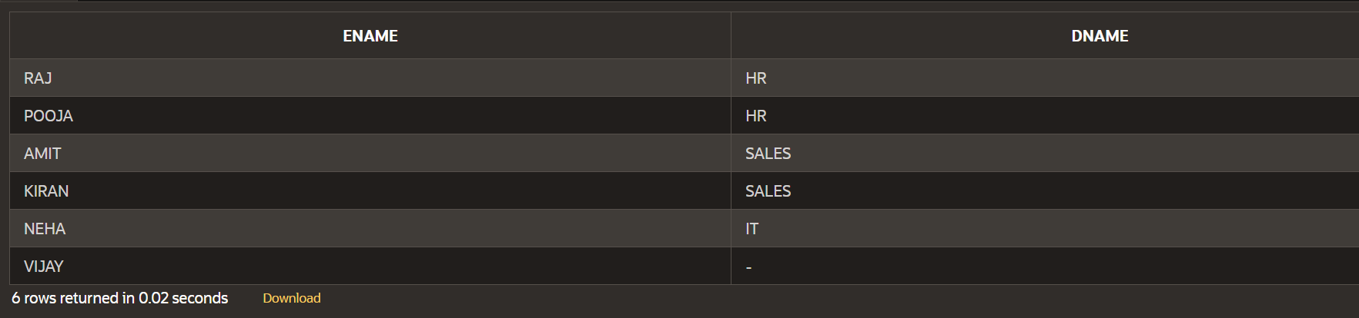
11. Retrieve all departments and their employees, including departments without
employees.
SELECT e.ename, d.dname FROM Emp e
RIGHT JOIN Dept d ON e.deptno = d.deptno;
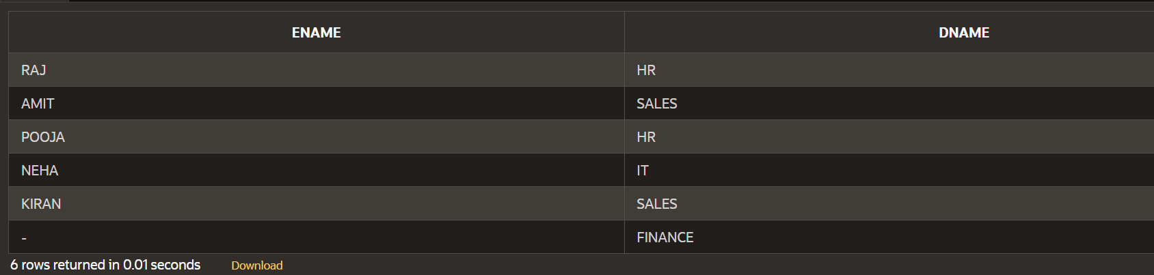
12. Retrieve all employees and departments.
SELECT e.ename, d.dname FROM Emp e
FULL OUTER JOIN Dept d ON e.deptno = d.deptno;
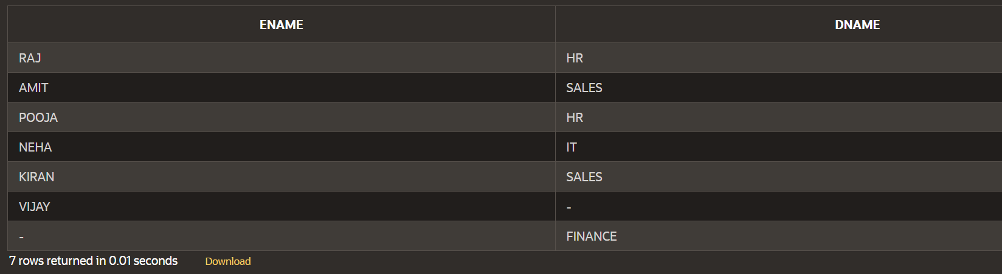
13. Retrieve employees and their department names, sorting the result by
department name in ascending order.
SELECT e.ename, d.dname FROM Emp e
JOIN Dept d ON e.deptno = d.deptno
ORDER BY d.dname ASC;
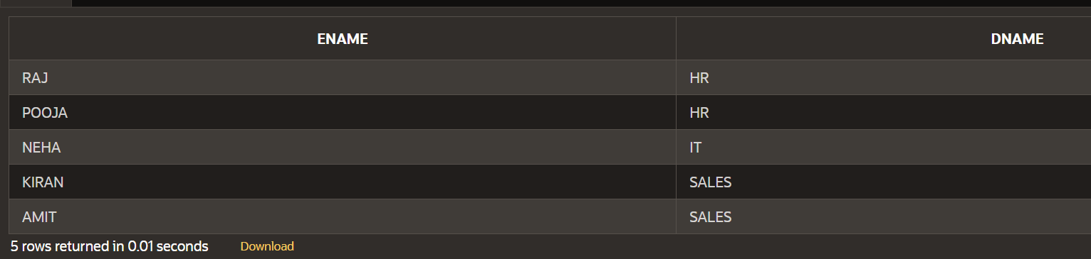
14. Retrieve all customers and their deposit amounts, including those without
deposits.
SELECT c.cname, d.amount FROM Customer c
LEFT JOIN Deposit d ON c.cname = d.cname;
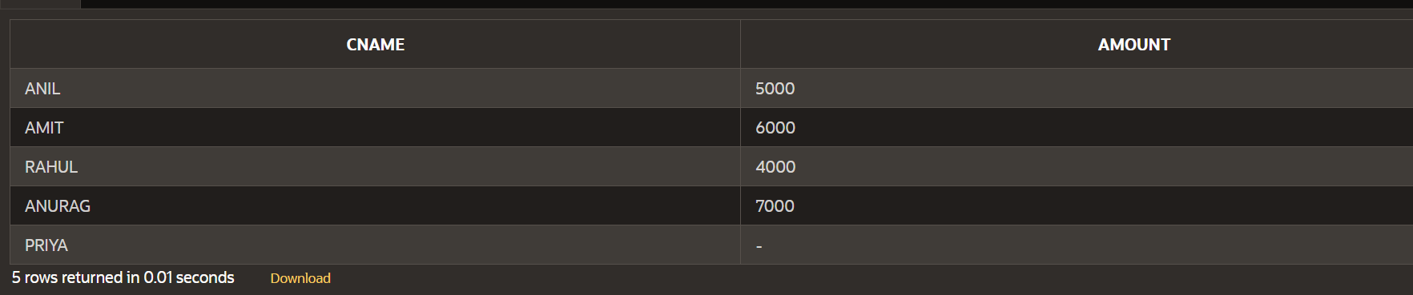
15. Retrieve all deposits and the corresponding customer information, including
deposits without associated customers.
SELECT c.cname, d.actno, d.amount FROM Deposit d
LEFT JOIN Customer c ON d.cname = c.cname;
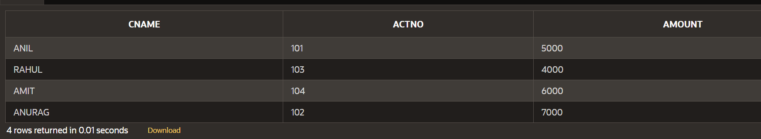
16. Retrieve all customers and deposits, including those without matches on either side.
SELECT c.cname, d.actno, d.amount FROM Customer c
FULL OUTER JOIN Deposit d ON c.cname = d.cname;
